**COMSATS UNIVERSITY ISLAMABAD**

**MOBILE APPLICATION DEVELOPMENT**

**LAB MIDTERM**

**Group Members: Registration No:**

Fatima Hameed FA19-BCS-022

Kulsoom Khurshid SP20-BCS-044

Mina Ellahi SP20-BCS-051

Hammad Tufail SP20-BCS-028

**Project Title**

Hospital Management System (eHOSPITAL)

**Figma Links**

* Figma Link by Mina Ellahi:

<https://www.figma.com/file/VPieq26TZnK9gZQtaf1grY/DoctorSide?node-id=0%3A1&t=j0mmEQszTqp0BzdG-0>

* Figma link by Kulsoom

<https://www.figma.com/file/a9EqEil2qS3yU5ufPhDOE6/Admin-Portal?node-id=0%3A1&t=Ub3X610Fte0mfAbD-0>

Prototype:

<https://www.figma.com/proto/a9EqEil2qS3yU5ufPhDOE6/Admin-Portal?node-id=1%3A2&scaling=scale-down&page-id=0%3A1&starting-point-node-id=1%3A2>

* Figma link by Hammad

<https://www.figma.com/file/t1tiuaX19xefAGSXNqIcRr/Doctors-app?node-id=0%3A1&t=OYmwIwKfLnFn0gil-0>

* Figma link by Fatima

<https://www.figma.com/file/gF8bBfEDYBhwMPB6HQsL5L/Ehospital?node-id=0%3A1&t=G68OEUV0QmLNMruC-0>

**Screen Description:**

**Kulsoom Khurshid (044) – Admin Portal**

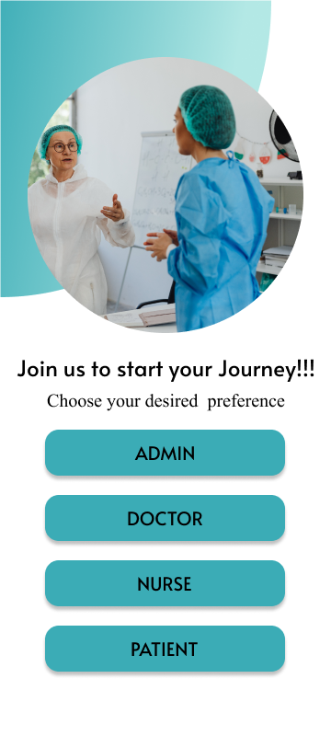

**Screen: 1**

**Start-up Screen**

**Group Member:** Kulsoom Khurshid

* The user can select any option.
* If the user is admin click on admin and it will move to the admin portal.
* The user can be doctor, nurse and patient.

**Screen 2: Admin login**

**Group Member:** Kulsoom Khurshid

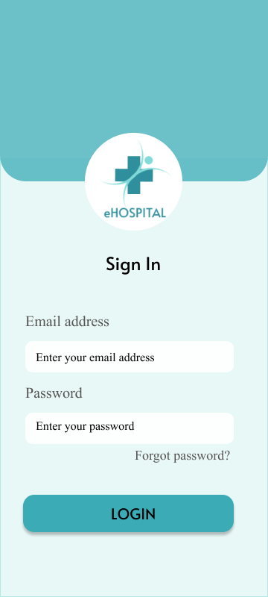

* The admin has to enter the email address. It should be according to the validation.
* Password is required if password is correct the admin is logged in.
* The user can also reset the password by clicking on forgot password.

**Screen 3: Forgot Password**

**Group Member:** Kulsoom Khurshid

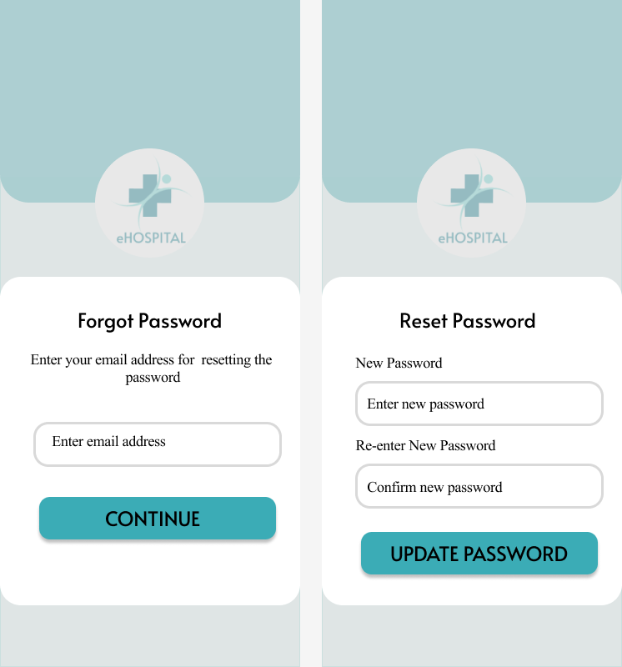

* The user has to enter the email.
* If the email matches the admin email it moves to next screen where the user can reset the password.
* The password should be according to the standards.

**Screen 4: Admin Dashboard**

**Group Member:** Kulsoom Khurshid

* 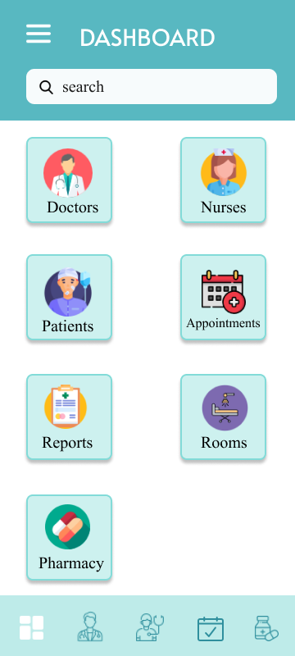The admin can select any of the 7 options available i.e., Doctors, nurses, patients, appointments, reports, room management, pharmacy.
* The admin can make changes.

**Screen 5: Admin Menu**

**Group Member:**  Kulsoom Khurshid

* 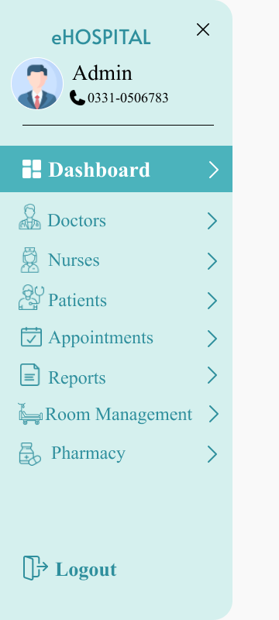 The admin can select any of the options from the side menu as well to make the changes in the system or view the record.

**Screen 6: Admin (Doctor Information)**

**Group Member:** Kulsoom Khurshid

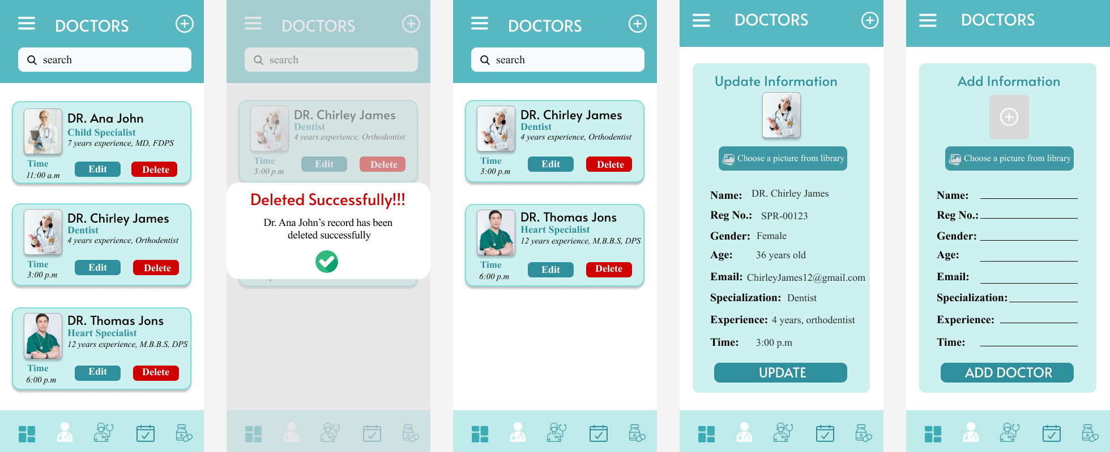

* The admin can view the doctor’s information.
* Admin can delete the doctor’s record by clicking on the delete button.
* Admin can also update doctor’s information by clicking on the edit button.
* The plus sign in the header can be used to add new doctor.

**Screen 7: Admin (Nurse Information)**

**Group Member:** Kulsoom Khurshid

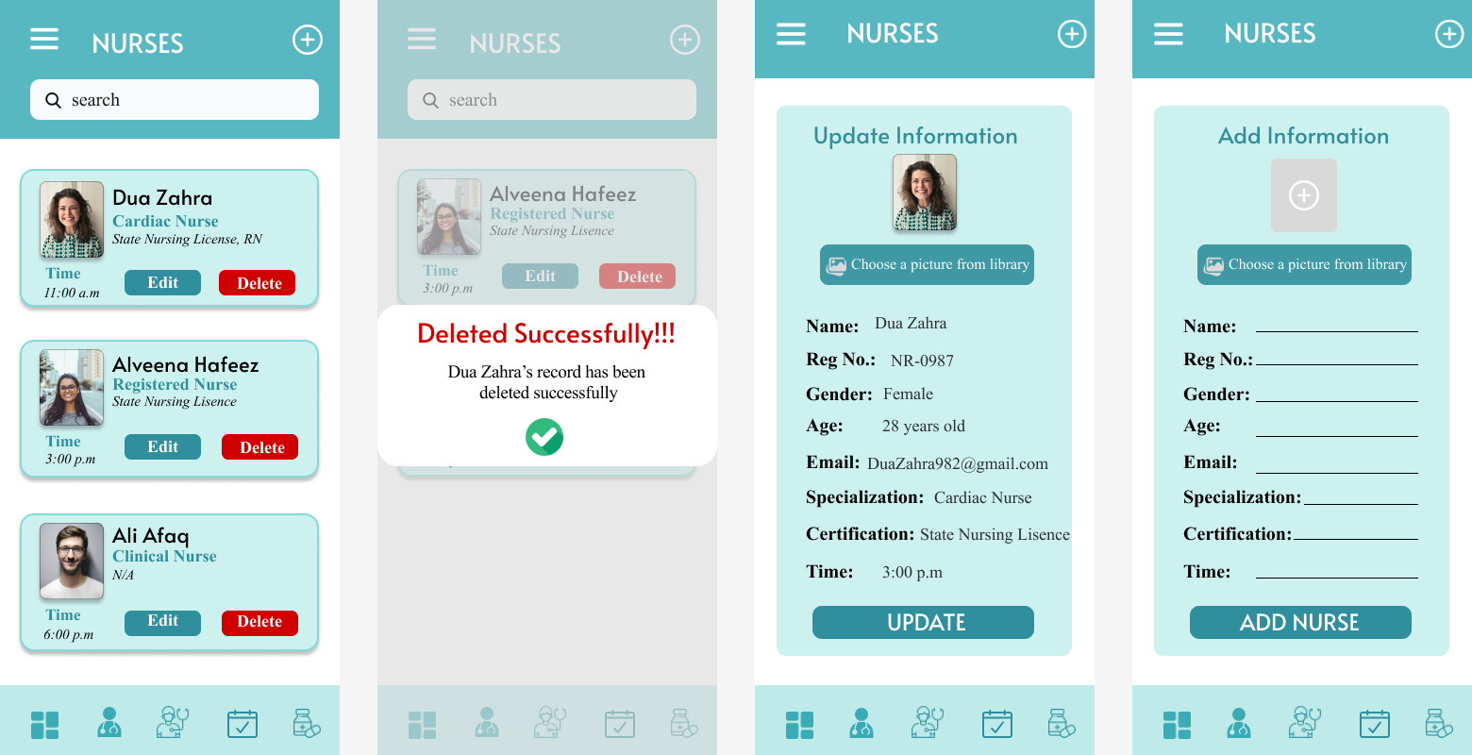

* The admin can view the nurse’s information.
* Admin can delete the nurse’s record by clicking on the delete button.
* Admin can also update nurse’s information by clicking on the edit button.
* The plus sign in the header can be used to add new nurse.

**Screen 8: Admin (Patient Information)**

**Group Member:** Kulsoom Khurshid

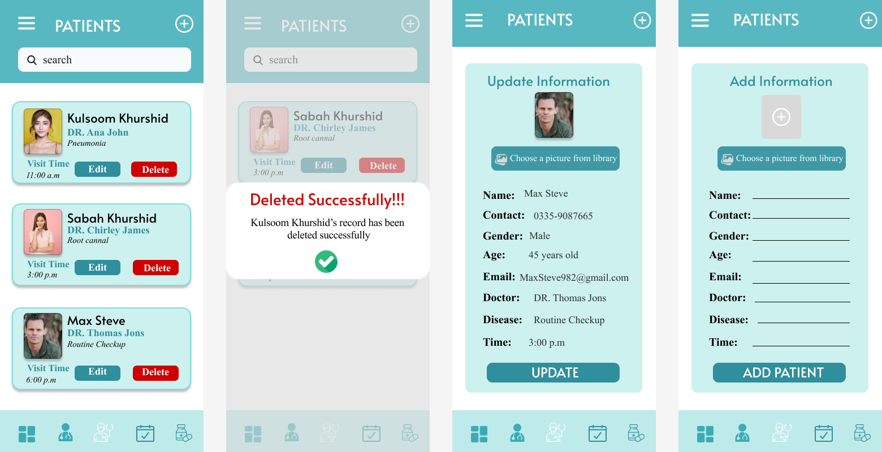

* The admin can view the patient’s information.
* Admin can delete the patient’s record by clicking on the delete button.
* Admin can also update patient’s information by clicking on the edit button.
* The plus sign in the header can be used to add new patient.

**Screen 8: Admin (Appointment Information)**

**Group Member:** Kulsoom Khurshid

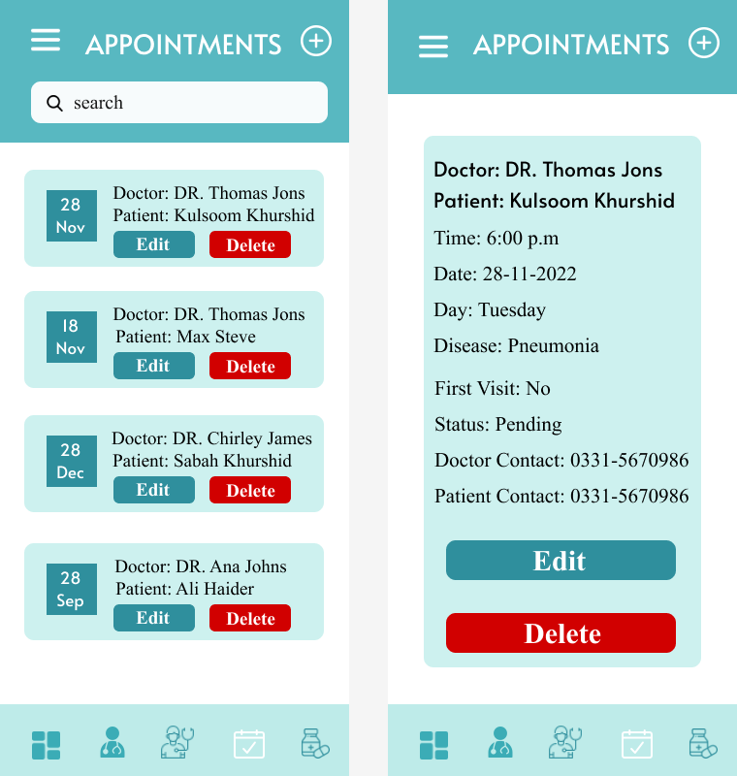

* The admin can view the information related to appointments.
* Admin can delete the Appointments by clicking on the delete button.
* Admin can also update appointments by clicking on the edit button.
* The plus sign in the header can be used to add new appointments.

**Screen 9: Admin (Record Information)**

**Group Member:** Kulsoom Khurshid

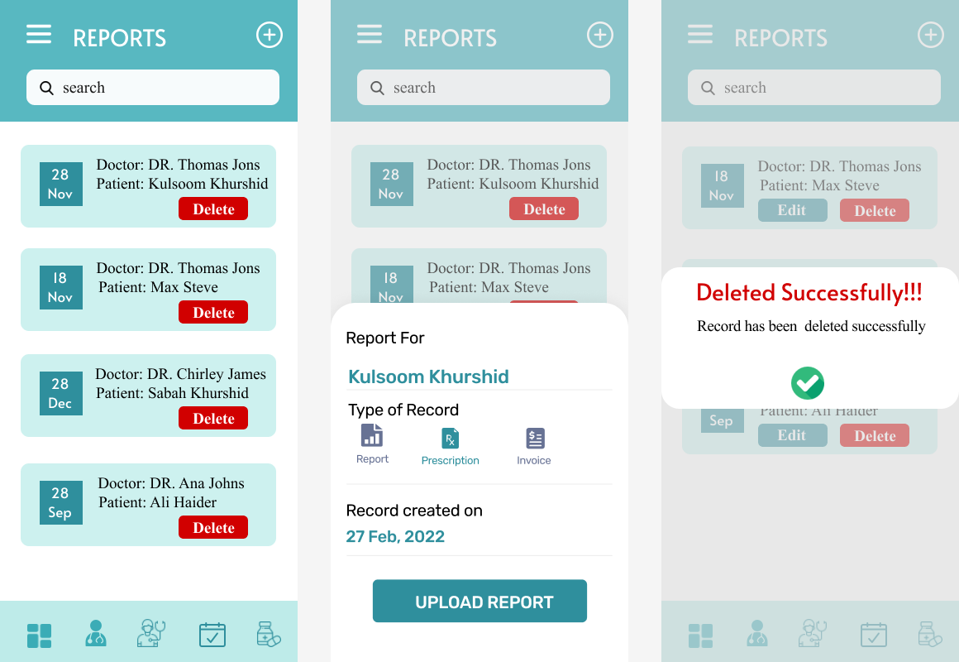

* The admin can view the information related to reports.
* Admin can delete the reports by clicking on the delete button.
* The plus sign in the header can be used to add new reports.
* A modal screen appears, the admin has to enter the name of the patient for whom the report is being entered.
* Admin has to select the type of report that is being entered. Prescription, Report or invoice can be added.
* The admin has to enter the date on which the record is being inserted.
* The admin can delete the record by clicking on the red button.

**Screen 10: Admin (Pharmacy Information)**

**Group Member:** Kulsoom Khurshid

* 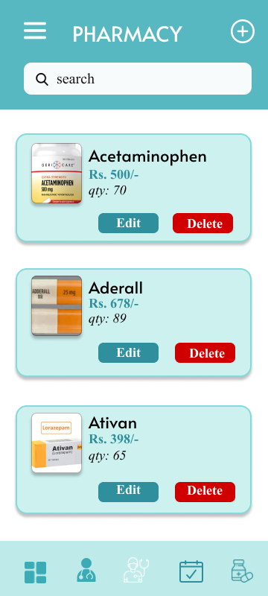The admin can view the information related to Medicines.
* Admin can delete the medicines by clicking on the delete button.
* Admin can also update medicines by clicking on the edit button.
* The plus sign in the header can be used to add new medicine.

**Doctor Portal (MINA ELLAHI)**

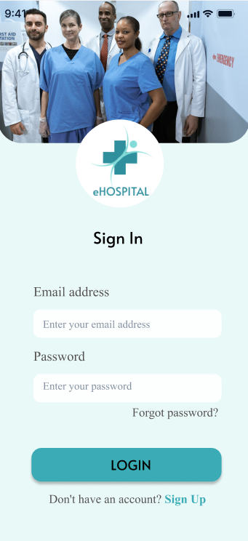

**Screen Number:** 2

**Group Member:** Mina Ellahi

**Description:** Doctor Sign in

a) Input the “Email” with the validation script

b) “Password” validation with 8 digits minimum, one capital word, and a special case letter

c) Disable the “Login” button, if any input field is empty

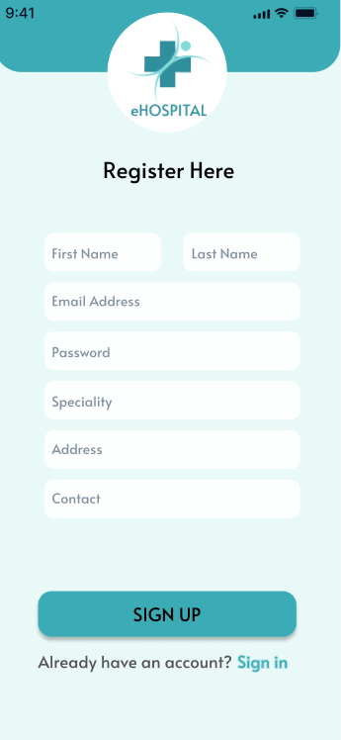

**Screen Number:** 3

**Group Member:** Mina Ellahi

**Description:** Doctor Registration

a) Input email with validated script

b) “Password” validation with 8 digits minimum, one capital word, and a special case letter

c)sign up button should be disabled if anything is missed

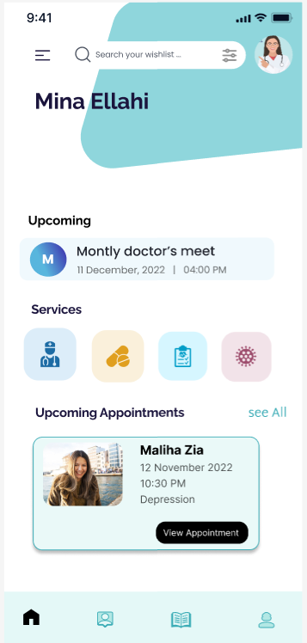

**Screen Number:** 3

**Group Member:** Mina Ellahi

**Description:** Doctor Dashboard

1. upcoming appointments can be viewed by pressing view all
2. side and bottom navigation is present

**Screen Number:** 4

**Group Member:** Mina Ellahi

**Description:** Doctor Side Navigation

1. Toggle button is present on the side. When it is pressed side navigation opens.
2. It shows different options like home, profile, patients, myAppointments, setting. Clicking on each one will take it to the respective page.

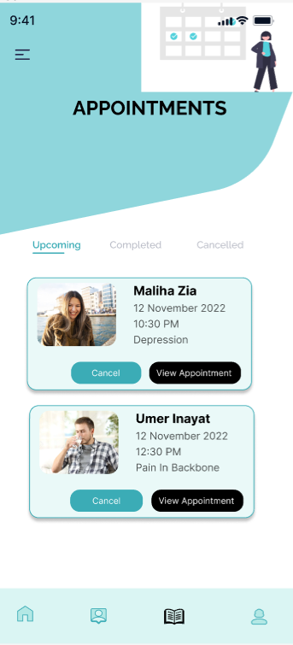

**Screen Number:** 5

**Group Member:** Mina Ellahi

**Description:** Doctor Appointment

1. This screen shows the upcoming appointment list
2. Two buttons are present
3. The doctor can cancel the appointment
4. The doctor can view the appointment by clicking on the view Appointment button

**Screen Number:** 6

**Group Member:** Mina Ellahi

**Description:** Doctor Appointment Cancellation

1. this pop up is shown when the doctor cancels the request

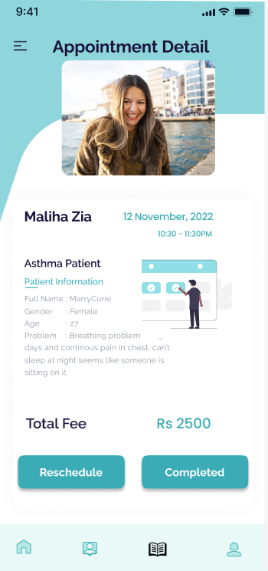

**Screen Number:** 7

**Group Member:** Mina Ellahi

**Description:** Doctor Appointment Detail

1. The profile of the patient and the time of the appointment is shown.
2. The doctor can either reschedule the appointment or press complete when it is done.

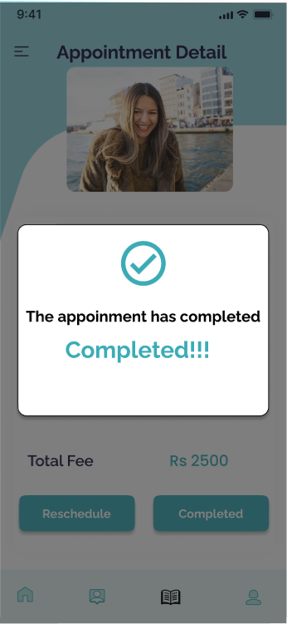

**Screen Number:** 8

**Group Member:** Mina Ellahi

**Description:** Doctor Appointment Completed

1. When the doctor complete the appointment a pop up appear

**Screen Number:** 9

**Group Member:** Mina Ellahi

**Description:** Doctor Appointment Reschedule

1. This screen appears when doctor presses reschedule button
2. The patient name will be automatically filled in the textinput
3. The date and time will be placed according to proper format
4. If any text input is left blank the button will be disabled

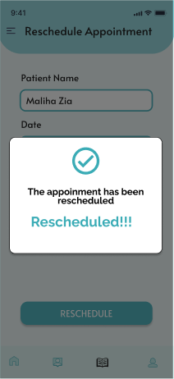

**Screen Number:** 10

**Group Member:** Mina Ellahi

**Description:** Doctor Appointment Reschedule Complete

1. Text, chat or text message

   Description automatically generateda popup will appear after the appointment is rescheduled

**Screen Number:** 11

**Group Member:** Mina Ellahi

**Description:** Doctor Profile

1. when doctor presses profile icon or in navigation bar the detail of his/her profile appears
2. if he presses update button it will take it to update screen

**Screen Number:** 12

**Group Member:** Mina Ellahi

**Description:** Doctor Profile Update

1. the text input will be automatically filled and the doctor can change it and then press update profile button.

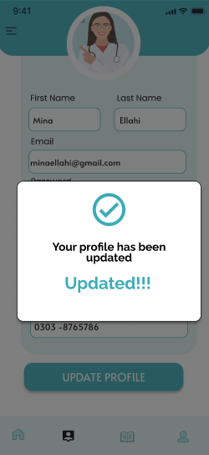

**Screen Number:** 13

**Group Member:** Mina Ellahi

**Description:** Doctor Profile Update Successful

1. a popup will appear after profile updating

**Fatima Hameed (022) – Patient Portal**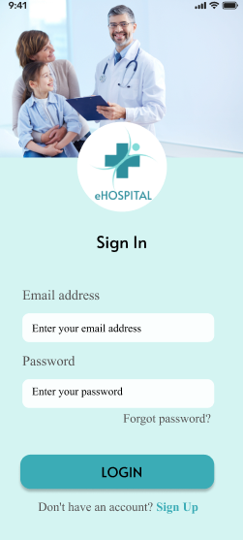

**Screen Number:** 14

**Group Member:** Fatima Hameed

**Description:** Patient Sign in

a) Input the “Email” with the validation script

b) “Password” validation with 8 digits minimum, one capital word, and a special case letter

c) Disable the “Login” button, if any input field is empty

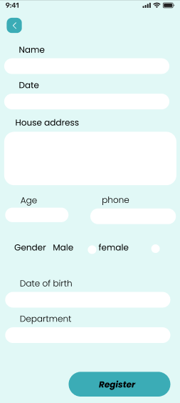

**Screen Number:** 15

**Group Member:** Fatima Hameed

**Description:** Patient Registration

a) Input email with validated script

b) “Password” validation with 8 digits minimum, one capital word, and a special case letter

c)Registration button should be disabled if anything is missed



**Screen Number:** 16

**Group Member:** Fatima Hameed

**Description:** Patient can view Doctor

1. a patient can view the popular doctor and click on it by booking the appointment

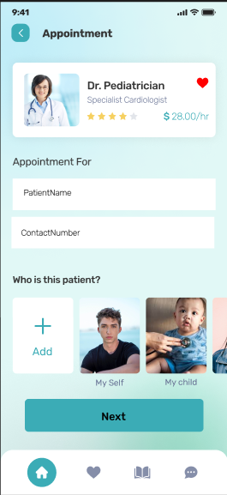

**Screen Number:** 17

**Group Member:** Fatima Hameed

**Description:** Patient appointment form

1. the patient name and contact number should be selected
2. 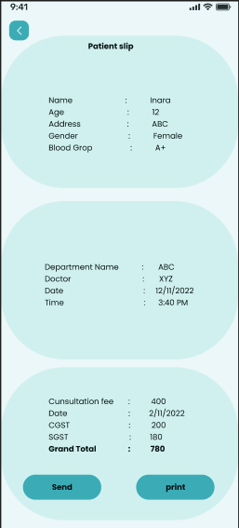next button should be pressed

**Screen Number:** 18

**Group Member:** Fatima Hameed

**Description:** Patient appointment slip

1. the description on the screen is given the user the print it and take it to the clinic

**Hammad Tufail (028) – Nurse Portal**

**Screen Number:** 1

**Group Member:** Hammad Tufail

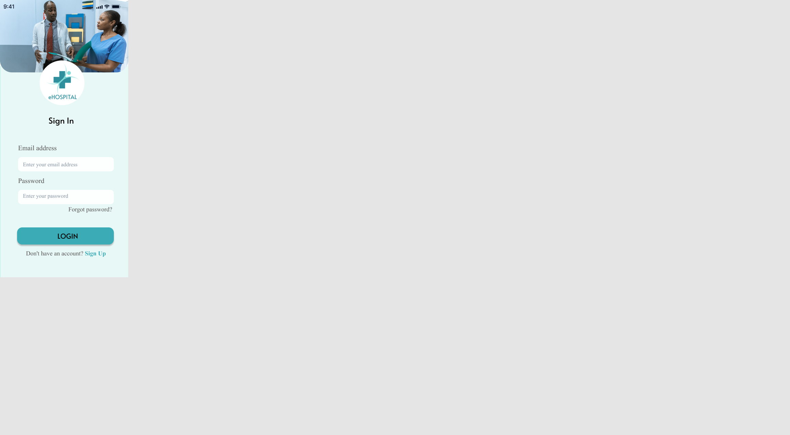

**Screen Number:** 2

**Group Member:** Hammad Tufail

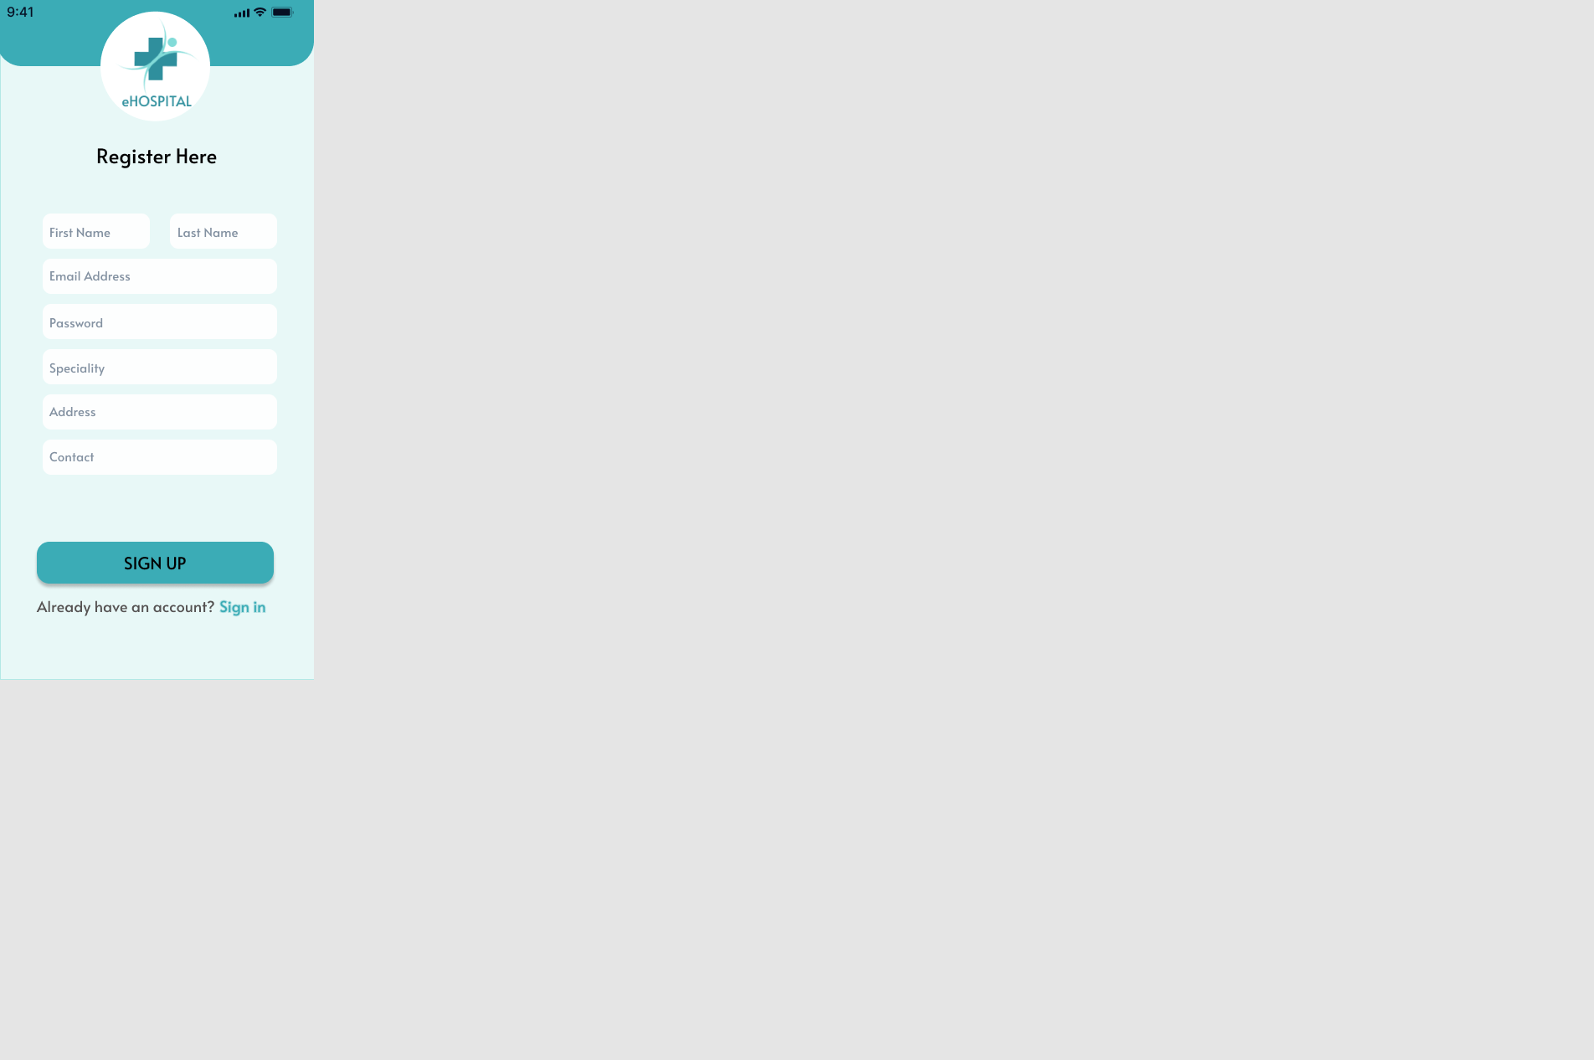

**Screen Number:** 3 & 4

**Group Member:** Hammad Tufail

